Rahvusvaheline hurtade maastikujooksu võistlus (CACIL) ja rahvuslik võistlus tõugudele, kes ei võistle CACILile
International Lure Coursing Competition (CACIL) and national competition for breeds not eligible for CACIL
15.05.2011 Harjumaa, Saue

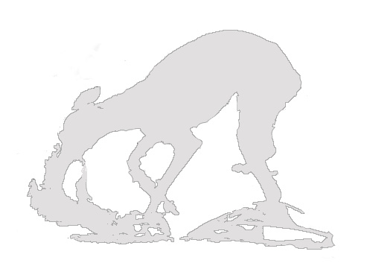

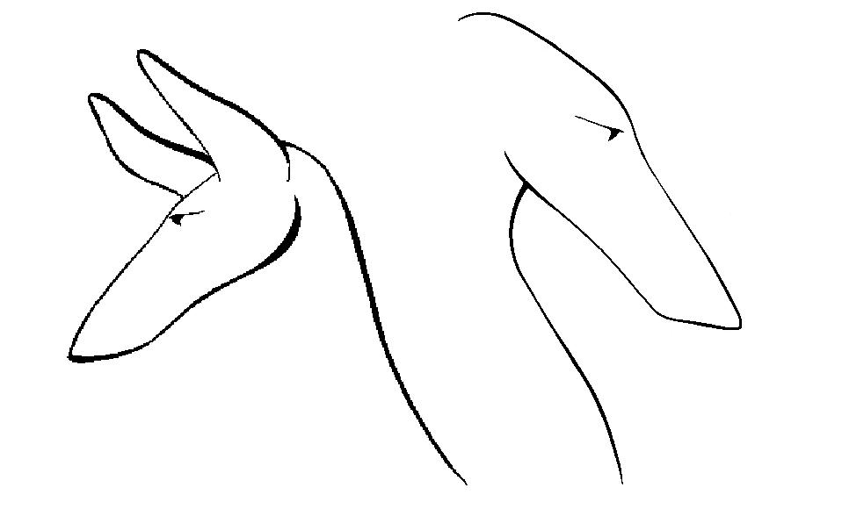
Eesti Hurtade Liit
Rahvusvaheline hurtade maastikujooksu võistlus (CACIL) ja rahvuslik võistlus tõguduele, kes CACILile ei võistle
International Lure Coursing Competition (CACIL) and national competition for breeds not eligible for CACIL
15.05.2011 Harjumaa, Saue

TOIMKOND

Peakohtunik Kalle Salovaara

Kohtunik Mika Nyman
Katrin Raie (va itaalia väikehurdad)

Toimkonna esimees Katrin Raie
Sekretär Liina Vaher

Vet. teenistus Ulla Ostra

Rajameister Raimond Kuusepalu

Peibutise vedaja Raimond Kuusepalu

Saatja Kairi Vahar, Iren Naarits
Kataloog Liina Vaher

AJAKAVA

09.00 vet. kontroll
10.00 eeljooksud, vet. kontroll finaaljooksudele pääsenud koertele
alates 12.30 finaaljooksud

Eriauhinna päeva suurima punktisummaga whippetile on välja pannud Liisa Vesik.

Eesti Hurtade Liitu toetab Bramham Trade AS.

OSALEVAD KOERAD
NR | Koera nimi | Sugu | Omanik | Reg.Nr | JR. | AVA | FINAAL | KOKKU | TULEMUS
 | Rodheesia ridgebackid
1 | Mbwasimba Mwujiza Fabayo | Male | P.Sihvonen, FI | FIN24548/03 | 1347 | 152 | 205 | 357 | ¼
2 | Harjaselän Pilkku | Female | E. Tiittala, FI | EJ12201/07 | 1429 | 234 | 94 | 328 | 2/4
3 | Bawabu Samara Sayidana | Female | K. Pesonen, FI | FIN27000/03 | 1364 | 158 | 131 | 289 | ¾
4 | Bawabu Vamoya Wamweru | Female | K. Pesonen, FI | FIN36794/05 | 1397 | 249 | 0 | 249 | 4/4
 | Borzoi
5 | Anna-Su Xena Fighter | Female | S. Luukkanen, FI | FIN37961/09 | 1790 | 119 | vigastus | 119 | 7/9
6 | Anna-Su Walice Fresh | Female | S. Luukkanen, FI | FIN48653/07 | 1031 | 179 | 71 | 250 | 3/9
7 | Rusich Volshebnitsa | Female | S.Fomin, EE | EST-03653/07 |  | 134 | - | 134 | 6/9
8 | Philadelphian Sabanna Charodei Chernij | Male | S. Fomin, EE | EST-03695/08 |  | disq | - | - | -/9 DISQ
9 | Philadelphian Sabanna Charunja | Female | R. Teek, EE | EST-03690/08 |  | 0 | - | 0 | 8/9
10 | Exlibris Canes Krasnaja Strela | Female | E. Kasmann, EE | EST-03809/07 | 0079 | 150 | loobus | 150 | 5/9
11 | Anna-Su Wladimir | Male | T. Sydänmäki, FI | FIN48652/07 | 1037 | 182 | 158 | 340 | 2/9
12 | Estet Classic Baronessa | Female | O. Gorbatshova &E. Rahamägi, EE | EST-02999/08 | 107 | 224 | 191 | 415 | 1/9 SERT, CACIL
44 | Inuschka Bistkupstwo | Female | M. Sugailo & V.Petrov, EE | EST02293/10 | 127 | 180 | vigastus | 180 | 4/9
 | Saluki
13 | Aziz Cane Zadan | Male | S. & P. Tavasti, FI | FI38445/07 | 990 | 249 | 221 | 470 | 1/5 SERT
14 | Azis Uzziah | Male | S. Tavasti, FI | FIN45040/03 | 3273 | 202 | 249 | 451 | 2/5
15 | Muàzzaz Ashayan | Female | K. Ruut&A. Mäklin, EE | FIN30212/08 | 1138 | 32 | - | 32 | 5/5
16 | Almeisan J´Aime Lorenso | Male | T. Karaulova, EE | EST-03144/07 |  |  |  |  | Ei osalenud
17 | Aleisan Joell Vincente | Male | L. Molokova, EE | ES-03145/07 | 121 | 237 | 186 | 423 | 3/5 SK
18 | Aziz Baji | Female | P.&T. Savolainen, FI | FIN15479/07 | 880 | 205 | 15 | 220 | 4/5
 | Shoti hirvekoer
19 | Baylind Hepburn to Blixten | Female | I. Arhima&K.-Oinonen&M-L.Arhima-Oinonen, FI | FIN15034/05 | 184 | disq | - | - | -/6 DISQ
20 | Blixten the Great Scott | Male | I. Arhima&K.-Oinonen&M-L.Arhima-Oinonen, FI | FIN17891/06 | 607 | 188 | loobus | 188 | 2/6
21 | Blixten Born To Be Wild | Female | I. Arhima&K.-Oinonen&M-L.Arhima-Oinonen, FI | FIN33596/08 | 1454 | 45 | - | 45 | 4/6
22 | Bixten Brake A Way | Female | I. Arhima&K.-Oinonen&M-L.Arhima-Oinonen, FI | FIN33600/08 | 1455 | 116 | - | 116 | 3/6
23 | Blixten Blowing Wind | Female | I. Arhima&K.-Oinonen&M-L.Arhima-Oinonen, FI | FIN33597/08 | 1457 | 0 | - | 0 | 5/6
24 | Kilbourne Harvest Moon | Male | .I Arhima&K.-Oinonen&M-L.Arhima-Oinonen, FI | FIN52666/09 | 1528 | 208 | 254 | 462 | 1/6 SERT, CACIL
 | Afganistaani hurt
25 | Oshanameh`s I Bet I´m Better | Female | I. Naarits &O. Tukkila | EST-02350/09 | 113 | 235 | 260 | 495 | ½ SERT
26 | Oshanameh`s Hubba Hubba | Female | I. Naarits, EE | EST-03248/08 | 100 | 236 | loobus | 236 | 2/2
 | Whippet
27 | Pikkuneidin Born To Be Wild | Female | K. & S. Lampola, FI | FIN53861/07 | 1113 |  |  |  | Ei osalenud
28 | Besties Lakupekka | Male | H.Niemi, FI | FIN55179/07 | 1128 | 219 | 158 | 377 | 5/6
29 | Born To Charm Mik Jager | Male | V. Mahrova, EE | EST-03904/08 | 102 | 220 | 240 | 460 | 2/6 SERT, R-CACIL
30 | Sökövintin JX Bernadette | Female | K. Lampola, FI | FIN23779/05 | 406 | 248 | 202 | 450 | 3/6 SK
31 | Theodor Circus Maximus | Male | V. Mahrova, EE | EST-03521/05 | 52 | 0 | - | 0 | 6/6
32 | Born To Charm Mirabel | Female | S. Baranin, EE | EST-03901/08 | 104 | 213 | 257 | 470 | 1/6 SERT, CACIL, EH
33 | Satangin Just My Magic | Female | N. Krassilnikova, EE | EST-02540/05 | 44 | 224 | 158 | 382 | 4/6
 | Basenji
34 | Safeguard's Diamond Dayna | Female | A. Lind, EE | EST-00761/09 | 110 | 267 | 223 | 490 | 1/7 SERT
35 | Solebas Beautiful Brilliant | Female | A. Aavik, EE | EST00522/10 | 117 | 0 | - | 0 | 5-7/7
36 | Solebas Braking News | Female | T. Tootmaa & M.Bachman, EE | EST-00519/10 | 119 | 0 | - | 0 | 5-7/7
37 | Solebas Bright Spirit | Female | K. Tilk, EE | EST-00523/10 |  | 228 | 185 | 413 | 3/7 SERT
38 | Solebas Attractive Ally | Female | T.Tootmaa, EE | EST-00262/08 | 80 | 118 | - | 118 | 4/7
39 | Strong Stael Dea Angella | Female | T.Tootmaa, EE | EST-02954/04 | 41 | 0 | - | 0 | 5-7/7
40 | Solebas A Dream Action | Male | E. Rebane, EE | EST-00260/08 | 90 | 224 | 216 | 440 | 2/7 SK
41 | Itaalia väikehurt
42 | Pikkuneitin Primavera | Female | K. &S. Lampola, FI | FIN40288/06 | 610 | 231 | 91 | 322 | ½
43 | Dragonhunter a Night At the Opera | Male | E. Laherand &K. Raie, EE | EST-02073/08 | 93 | 0 | - | 0 | 2/2
Rhodeesia ridgebackid ja basenjid on tõud, mis FCI reeglite kohaselt ei võistle CACILile, ning osalevad seetõttu rahvuslikul võistlusel.
Rhodesian ridgebacks and basenjis are breeds that by FCI rules are not eligible for CACIL, which means they have a national competition.

